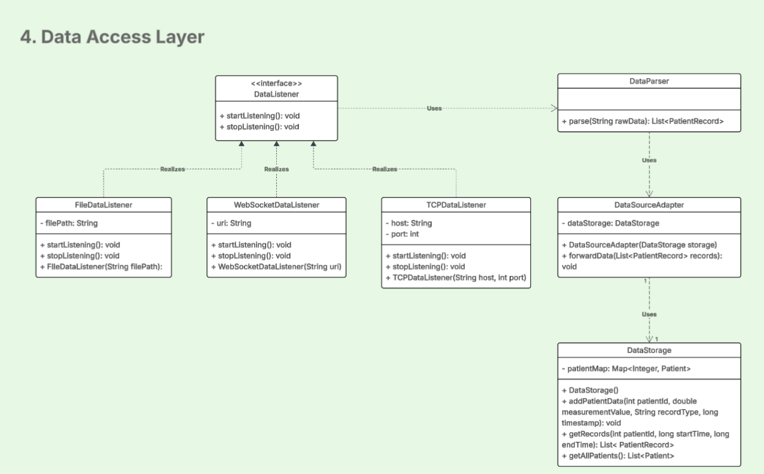

Data Access Layer represents a health monitoring system, responsible for retrieving and processing patient data from external sources such as TCP streams, WebSockets, and files. Its main design components include:

**DataListener interface**: defines a common contract (startListening() and stopListening()) for all types of data sources. This abstraction allows the system to remain flexible and easily extendable- new types of data sources can be integrated without modifying the rest of the system. Three classes- **TCPDataListener, WebSocketDataListener,** and **FileDataListener**—realize this interface, each following specific rules or input format.

**DataParser:** parses the data collected by listeners. It transforms raw input (i.e.: JSON, CSV) into structured PatientRecord objects.

**DataSourceAdapter:** acts as a mediator between the parsing logic and the system's internal storage. It uses the parser and forwards structured records to DataStorage.

**DataStorage:** stores patient data in a map and provides methods to retrieve and query it.